Episode 320: Superposition

This episode introduces the basic idea of superposition of waves, explaining what happens when two or more waves meet.

Summary
Discussion: Recapping wave ideas. (10 minutes)
Demonstration: Waves on a rope. (15 minutes)
Discussion: Ripples on a pool. (10 minutes)
Student questions: Adding waves graphically. (30 minutes)

Discussion:
Recapping wave ideas
Show a representation of a wave and rehearse basic knowledge about waves:
Frequency f is determined by the source of the waves (the “transmitter”)
Wave speed c is determined by the medium in or on which the wave propagates.
So wavelength follows from c = fλ  
At boundaries (reflection, refraction etc), f must stay the same.

Demonstration:
Waves on a rope etc
This is a useful attention grabber. Pass pulses through each other on a stretched rope, rubber tube or stick wave machine.
Set off a large amplitude pulse; just before the first pulse is reflected, chase it with a smaller amplitude pulse – observe that the pulses briefly combine then pass through each other, and carry on as before.
(For later comment, observe and note the phase change on reflection; that is, the pulse turns upside down when it reflects.)
Draw attention to this ‘damage-less collision’ of waves passing through each other that is a hallmark of all wave behaviour. Colliding particles rebound and may suffer damage. [The other hallmark of wave motion is that the speed of a wave is constant and determined by the medium supporting the wave motion. Unlike particles, ‘friction’ doesn’t reduce the speed; it reduces the energy (i.e. the amplitude) of the wave.]
When two waves arrive at the same point and at the same time, the resultant displacement is given by the algebraic sum of the two individual displacements. (‘Algebraic sum’ means that you have to take account of positive and negative values.)

Discussion:
Ripples on a pool
Superposition is an everyday phenomenon. Show some images of ripples on a pool of water as they pass through each other.

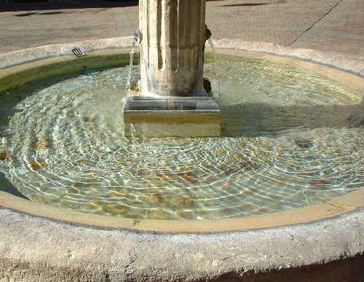
(Image: resourcefulphysics.org)

TAP 320-1: Overlapping ripples

Student questions:
Adding waves graphically
Drawing exercises reinforce the idea that, to find the displacement when two waves meet, you simply calculate the algebraic sum of the two individual displacements.

TAP 320-2: Phase difference and superposition
TAP 320-3: Superposition of waves: a drawing exercise

TAP 320 - 1: Overlapping ripples

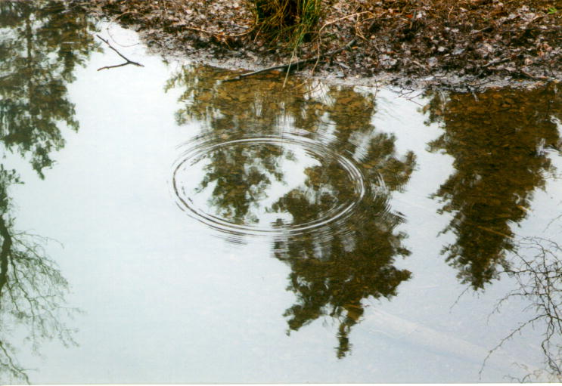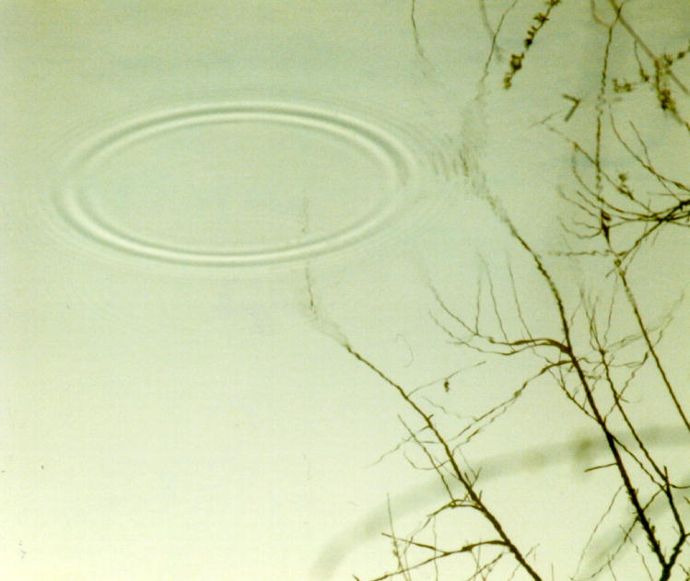

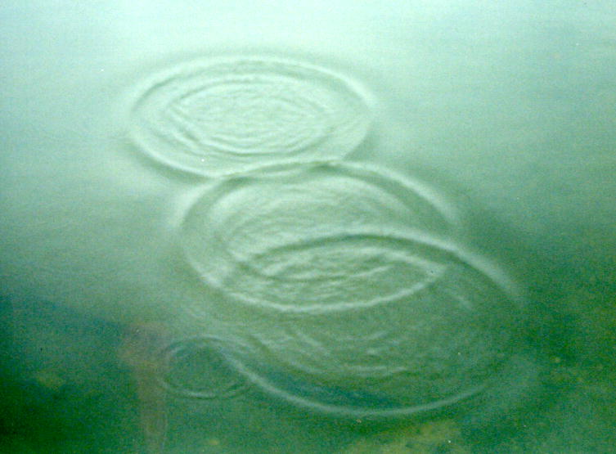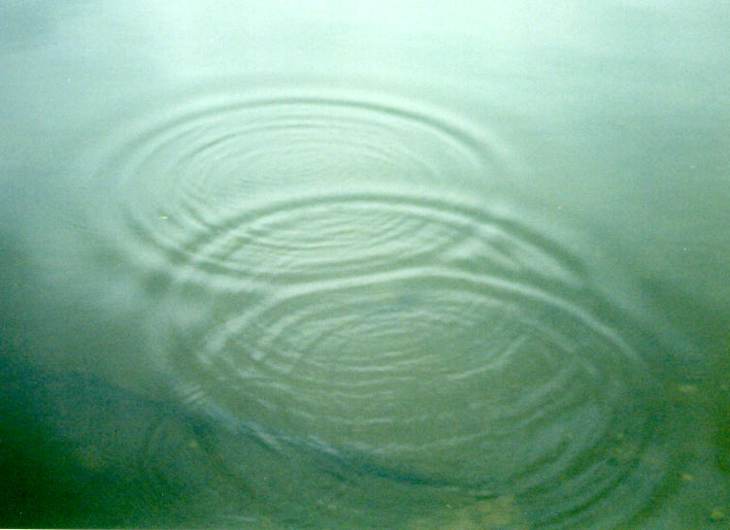

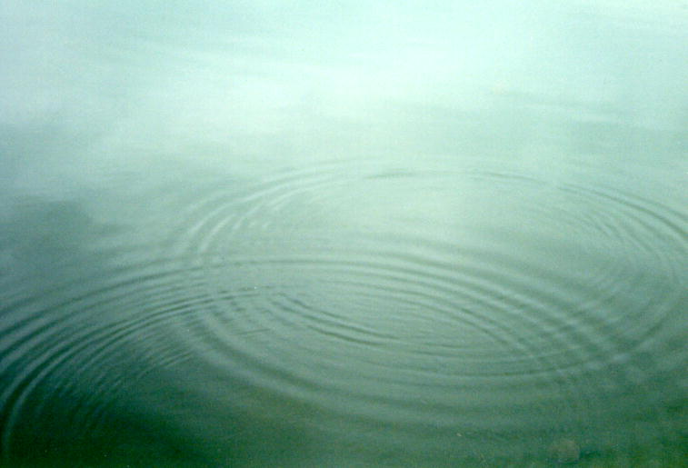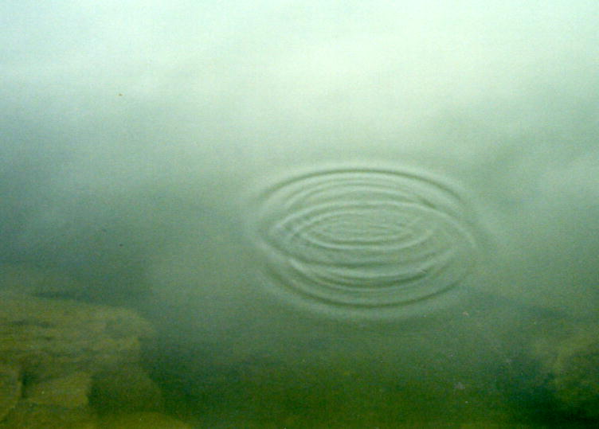

A simple story about one circular set of ripples, frozen in time becomes more complex and challenging when several sources produce overlapping patterns.

Practical advice
This set of images is provided to connect all the theorising about superposition to everyday experiences.

Alternative approaches
Images such as these are not too hard to capture and students might derive considerable pleasure in making some moving images, perhaps in order to discuss superposition.

Social and human context
It may have been images such as these, or more likely raindrops on puddles, that set Huygens off on his train of thought.

External reference
This activity is taken from Advancing Physics chapter 6, display material 40S

TAP 320 - 2: Phase difference and superposition

This question helps you check your understanding of phase difference and gives you further practice in superposing waves.

Graphs of waves

A graph of wave displacement against position shows a wave 'frozen' in space at an instant of time. Really, the waves are travelling along. The graph shows 'snapshots' of two waves, A and B.

1. What is the phase difference between A and B? Give your answers in fractions of a wavelength and degrees. There are at least two correct answers to this question!

2. Sketch the superposition pattern of A and B.

The next diagram shows two more waves, C and D.
3. What is the phase difference between C and D?

4. Sketch the superposition pattern of C and D.

5. What phase angle corresponds to a phase difference of 1/3 of a wavelength?

6. Sketch a diagram showing two waves of equal amplitude with a phase difference equal to 1/3 of a wavelength.

Practical advice
A suitable question to support demonstrations of superposition, phase and path difference.

Answers and worked solutions

1. Zero phase difference

2.

3. One oscillation (or wavelength for a displacement amplitude graph) is equivalent to 360º. Therefore:
$\begin{aligned}1/4 \text{wavelength} = \text{1/4} × \text{360}° = \text{90}° \\ \text{3/4} \text{wavelength} = 3/4 × \text{360}° = \text{270}°\text{.}\end{aligned}$

4.

5. $1/3 × \text{360}° = \text{120}°$

6.

External reference
This activity is taken from Advancing Physics chapter 6, 10W

TAP 320 - 3: Superposition of waves: a drawing exercise

This is a question on superposition of waves. You will need two pieces of A4 graph paper.

Superposing waves
The diagram below shows a snapshot of two waves approaching each other.

Take a sheet of A4 graph paper and copy the initial graph, taking up about one-quarter of the sheet.
1. Draw three new sets of axes, one below the other, and draw the waveform observed after one second, two seconds and three seconds. Label each!
2. You have drawn wave displacement against position graphs. On a separate sheet of graph paper draw a displacement against time graph for point P over the three second period.

Hints
1. Remember that a 'wave-profile' is like a 'snapshot'. One second later one wave will have moved 2 m to the right and the other 2 m to the left. Draw both waves in lightly and then draw the superposition pattern with a darker line. The superposition pattern is just the two waves added together.
2. At zero seconds point P is at zero displacement. Use your answers to part 2 to find the displacement of P at one, two and three seconds and plot these points on a displacement–time graph. Then think carefully about the movement of P during each second.

Practical advice
This gives further pencil and paper practice on ideas of superposition. Question 2 points to the important distinction between wave displacement–position graphs and displacement–time graphs.

Answers and worked solutions.

1

2.

External reference
This activity is taken from Advancing Physics chapter 6, display 20W

